|  |  |
| --- | --- |
| **Table of Contents** | **Page No** |
| **Introduction**  Purpose and scope of the study. | 5 |
| **Business Analysis**   1. Summarize the problem, the approach and assumptions made about the case and data. 2. Derive at least 6 and at most 8 business questions from the management concerns mentioned in the Case Study. | 5 - 6 |
| **Problem Solution**     1. Data Preparation:   Examine the data sources provided and carry out the cleansing / transformation using appropriate data analysis techniques in BI tool.   * + Data issues in the data sources   + Data cleansing /transformation rules used to resolve the data issues   + Extract (E), cleansing and transformation (T), load (L) results. Include diagrams and selected screen captures as necessary to aid description and explanation   + Screen capture ETL results and key steps      1. Data Analysis:   For each reporting requirement mentioned in the case study and the business questions derived earlier :   * + Data analysis approach/steps and techniques adopted. | 7 - 16              16 - 29 |
| * Reason for choosing the approach and techniques * Insights from the analysis result with diagrams and selected screen captures as necessary to aid description and explanation * Screen capture results and key steps |  |
| **Conclusions & Recommendations** | 30 |

### INTRODUCTION

The aim of this project is to investigate the limitations of the current system and develop ***Integrated Reporting System*** for ***Unity Sporting House (USH)*** to meet the requirements of the Business Plan. The main objective of this system is to create more value over time by integrating all the data and providing more holistic information about its sales, customers, products and manufacturers across all regions.

Business Intelligence System aims to gather in depth information from the company data and to analyse that data using different types of computer techniques and plotting which results in different types of graphs that facilitate the company in future decision. This system will provide clear and concise communication of organizations most important and relevant issues to their investors and other stakeholders. All the data should be integrated to produce **“*Single source of truth*”** for data across ALL regions. In short, this system is for better reporting which in turn leads to better decision making.

### BUSINESS ANALYSIS

1. **PROBLEM SUMMARY**

Unity Sporting House current data are in disparate system. It does not have clear view of which product lines, categories and brands are doing better in which region and which are more popular among different age groups and membership types.

Products are designed by its team of designers based in United States. Manufacturing is outsourced to contract manufacturers. Currently, Unity Sporting House work with more than twenty manufacturers.

Need a better system to maintain good relationship with customers, suppliers and stakeholders. All regions are linked together under Integrated supply chain system except Africa & Middle East. The management has not been able to get full picture of its sales and operations to enable it make good tactical and strategic decisions.

There are some data type incompatibilities, data format differences, Unit differences & missing and redundant data in the given datasets. We are designing an integrated dataset to overcome all these drawbacks.

1. **Business Questions from Management concerns**
2. Who are the top 15 customers, in terms of total amount spent by each one?

Dimension – Customer_ID,Customer_Name

Measure- Selling_Price

1. What is the number of days to deliver the sales order based on order type and region?

Dimension – Order_Type, Region

Measure – Days_To_Deliver

1. What are the number of orders on-time, late or very late by order type?

Dimension – Order_Type, Deliverystatus

Measure-Days_To_Deliver

1. What is the GrossProfit for each product?

Dimension – Product

Measure- Selling Price, Cost Price

1. Which are the top 15 best selling products (in terms of high profit)?

Dimension –Product_ID

Measure- GrossProfit

1. What is the mean gross profit based on Brand?

Dimension – Brand

Mearure- GrossProfit

1. Which manufacturer to continue and which to discontinue?

Dimension – ManufacturerName,

Measure-Quantity

### PROBLEM SOLUTION

1. **DATA PREPERATION**

**DATA ISSUES WITH THE DATA SOURCES:**

**ORDERS DATASET**-

* Data type incompatibilities –Order_ID, Customer_ID data type is not consistent across all the regions.
* Data Format Differences – Order_Type have different values across all the regions. Had few values like INTERNET, ONLINE, STORE, RETAIL_STORE, DEPT STORE.
* For some records, the order date is greater than the delivery date.

**CUSTOMER DATASET-**

* Data format differences – For Date of Birth, only birth year is given for all the regions except Africa & Middle East.
* Customer_ID got different for different regions.
* Customer Type for some records related to Middle East have no values filled in.
* In some records Customer Gender for Middle East is left blank.

**PRODUCT DATASET-**

* Missing product cost price, selling price & manufacturing id in records that are related to both Africa & Middle East.
* Product_ID is not consistent across all the regions.

**MANUFACTURER DATASET-**

* The column name manufacturer_id is not consistent with products dataset.

**DATA CLEANSING / TRANSFORMATION RULES :**

**PRODUCTS TABLE-**

* **Master Product_ID** - Created a new computed column using Advanced Expression for Africa & Middle East Product tables and tagged ‘660’ in front of Product_ID using CAT function. From here all the tables will be using master Product_ID .
* **Brand**- Some brand names for Africa table is updated with product information. Created a new new computed column using CASE expression to replace wrong brand names like shoes, stocking and trackers.
* **USH_ALL_PRODUCTS**- Created a full-outer table join to link the products across all the regions based on Product_Id. Selected distinct rows to avoid duplicates.
* **GROSS PROFIT** – Created a new computed column based on the difference between Selling price & Cost price.

**ORDERS TABLE-**

* **Product_ID**  is not consistent like Master Product_ID in products table. Created a new Advanced Expression for Africa & Middle East ORDERS table and to find the length of the string and tagged ‘660010’ , ‘660100’ using CAT function.
* **Days_To_Deliver–** Created a new computed column based on the difference between Delivery Date and Order Date.
* **Delivery Status-** This is a new recoded column based on the column Days_To_Deliver. There are three status like OnTime, Late & Very Late.
* **USH_ALL_ORDERS**- Created a full-outer table join to link thE ORDERS across all the regions based on Order_Id. Selected distinct rows to avoid duplicates.

**CUSTOMER TABLE -**

* **CUSTOMER_ID** – created a new master Customer_ID using SCAN function to extract the substring by delimeters like hyphen and underscore. From here, all the tables will be using master Customer_ID.
* **AGE**- Created a new computed column using Advanced Expression using INTCK function to find the age of the customer based on the date of birth.
* **Birth Year**- Created a new computed column using YEAR function to extract the birth year from DOB. From here all the tables will be using master DOB.
* **USH_ALL_CUSTOMERS**- Created a full-outer table join to link the CUSTOMERS across all the regions based on Customer_Id. Selected distinct rows to avoid duplicates.

Joined all the cleansed data into a single version of truth as ALL_TABLES. Now, its more meaningful to extract all the necessary information for USH without any duplications of data.

**ETL RESULTS**

**PROCESS FLOW-**

Transformed all the CUSTOMERS, ORDERS, PRODUCTS & MANUFACTURERS into a single data set.

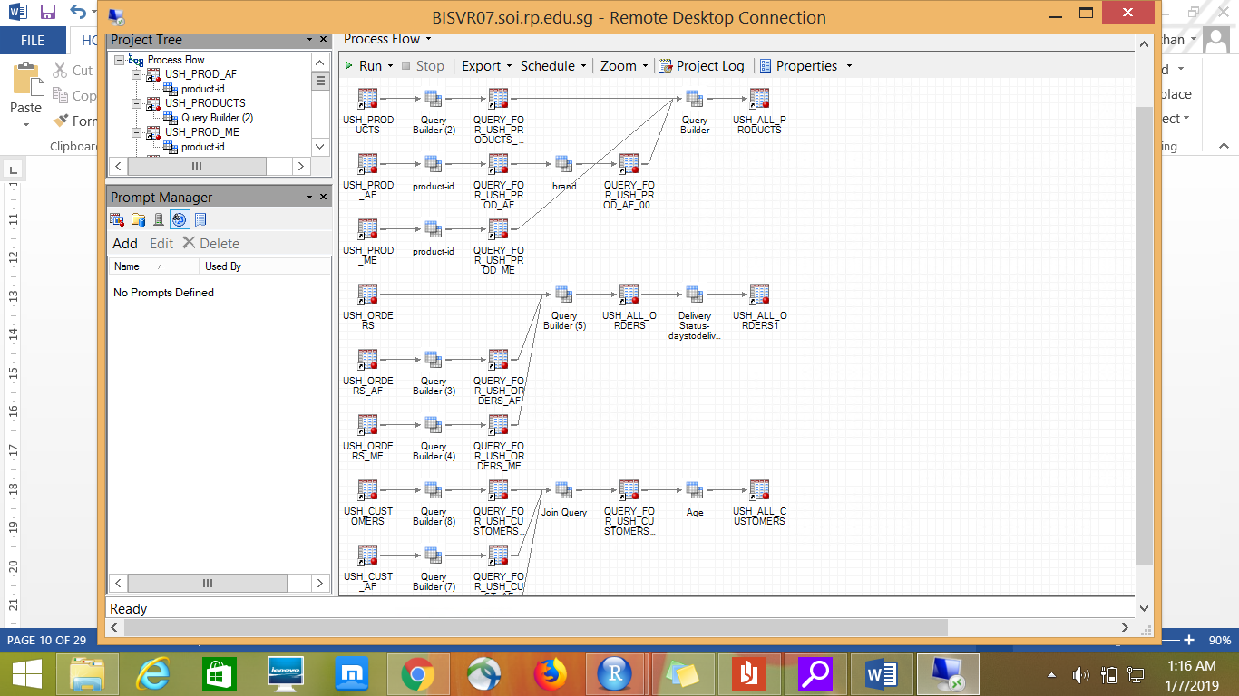

Recoded column for DeliveryStatus based on number of days to deliver in USH_ALL_ORDERS.

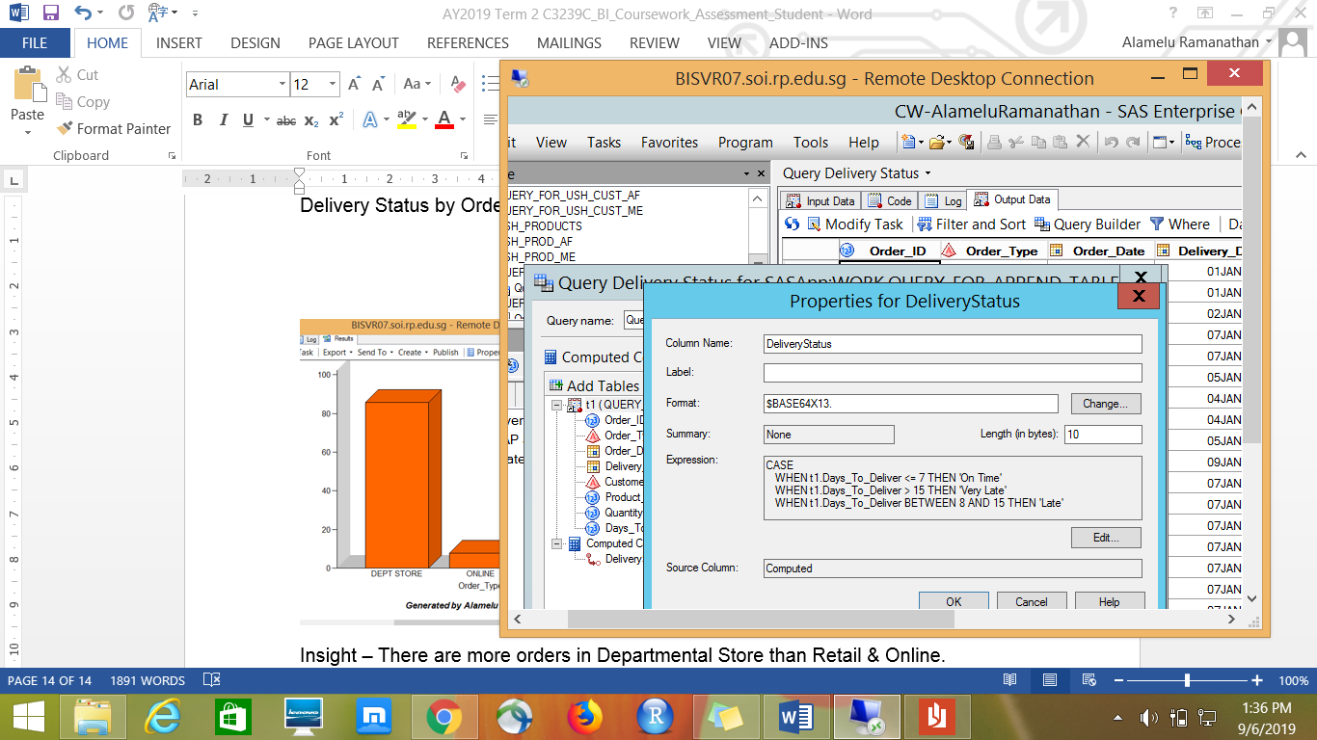

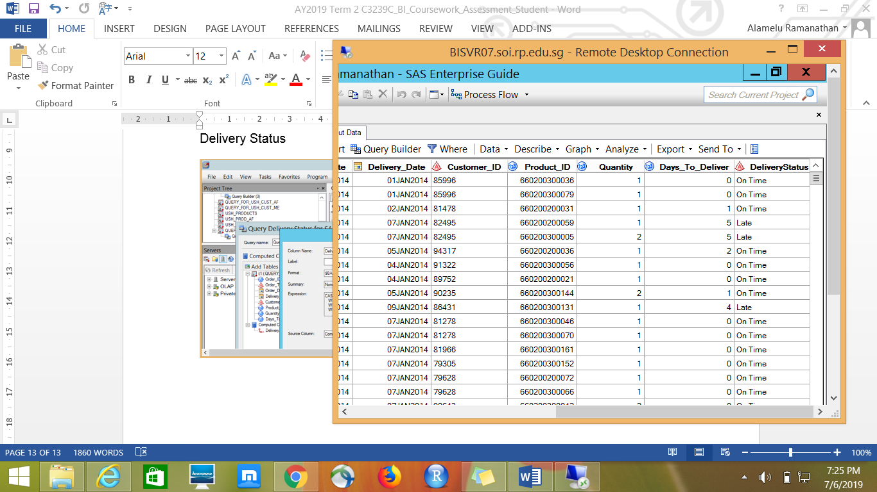

Recoded column to standardize OderType in USH_ALL_ORDERS

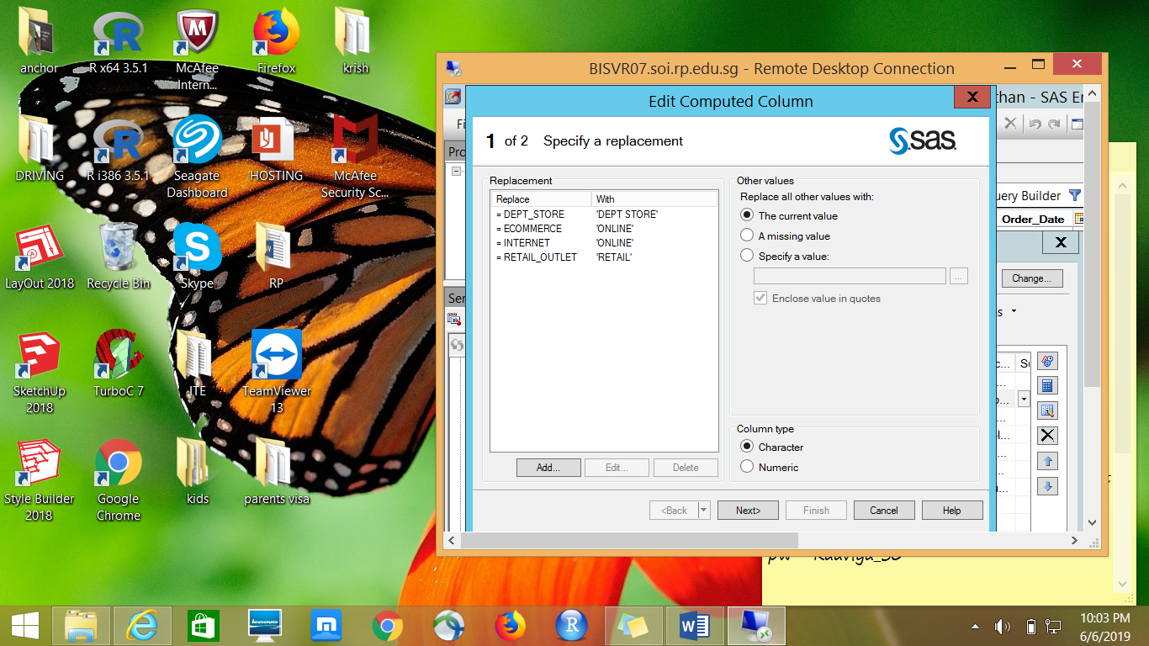

Extracting just the Year from the DateofBirth column in USH_CUSTOMERS for Africa & Middle East.

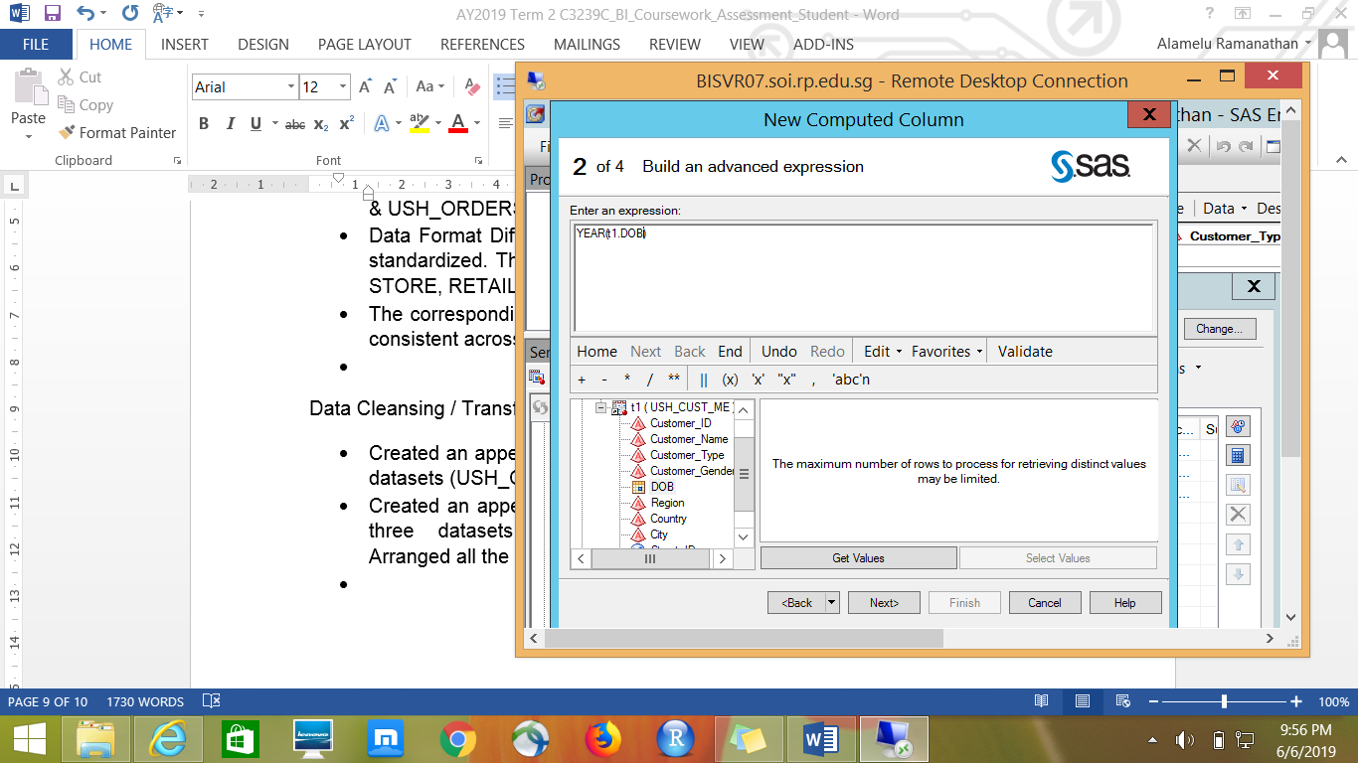

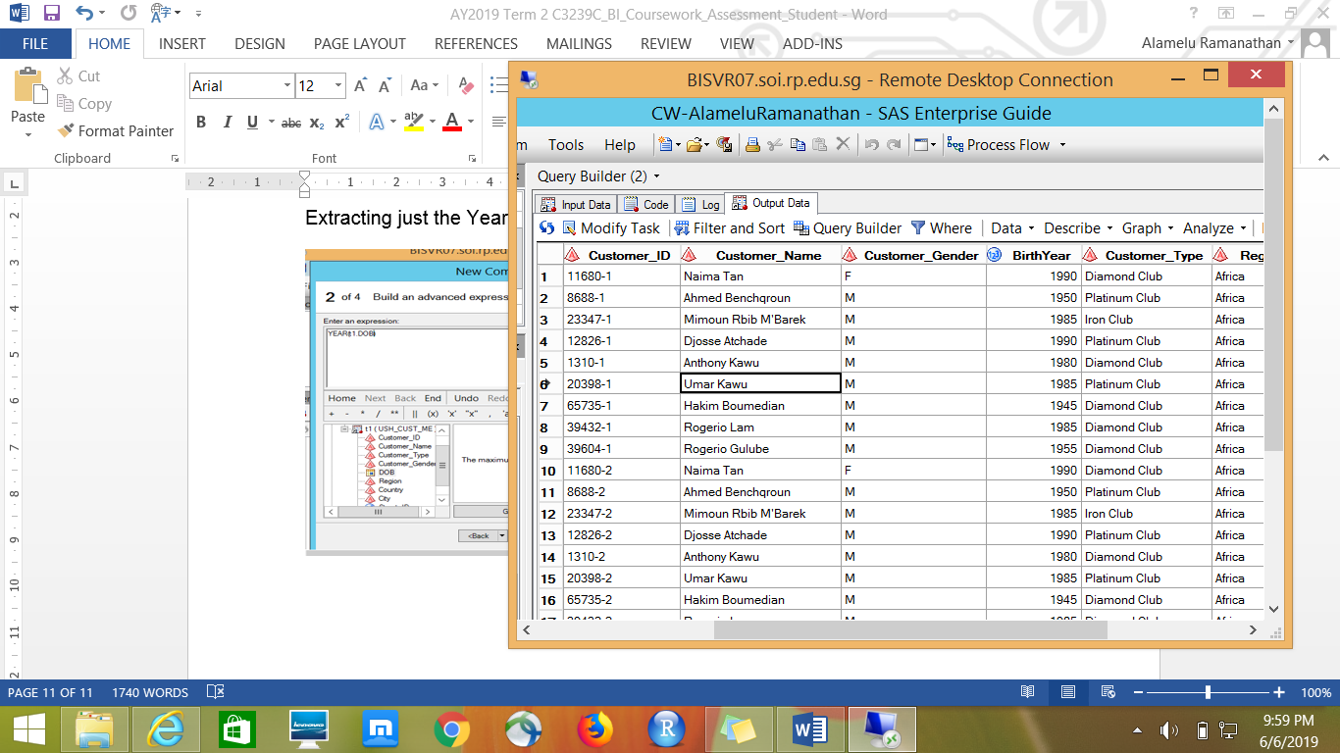

Advanced Expression to calculate Age using function INTCK in Customer table.

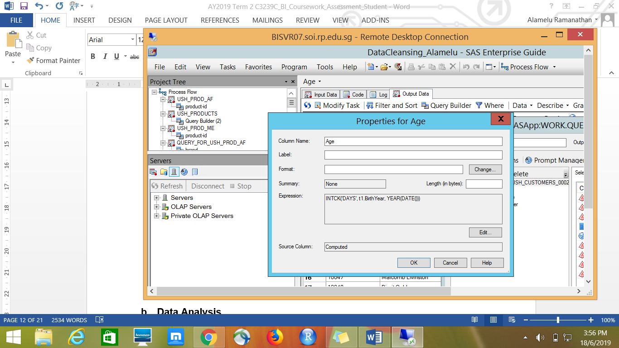

Using CAT function to create a master product_id for all the products across Africa and Middle East regions.

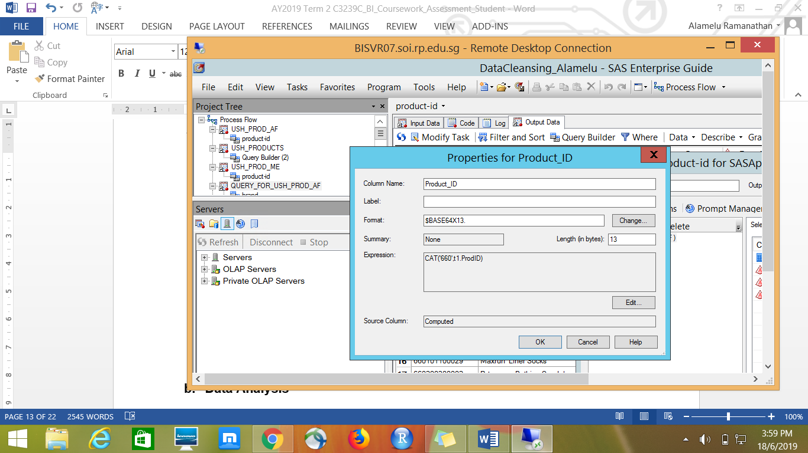

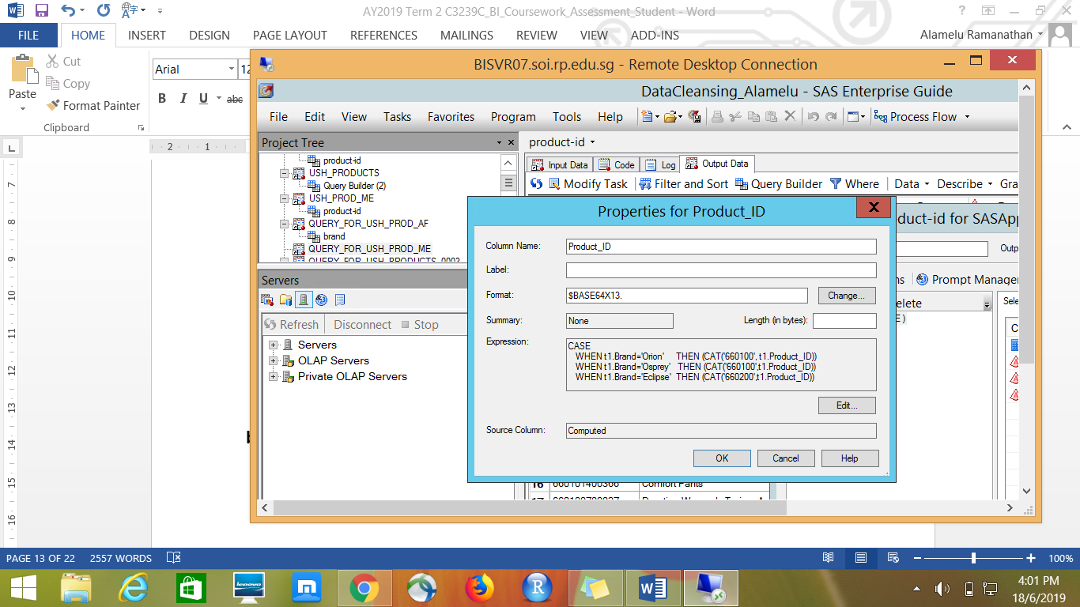

Standardized Brand Type across all the regions using CASE Expression.

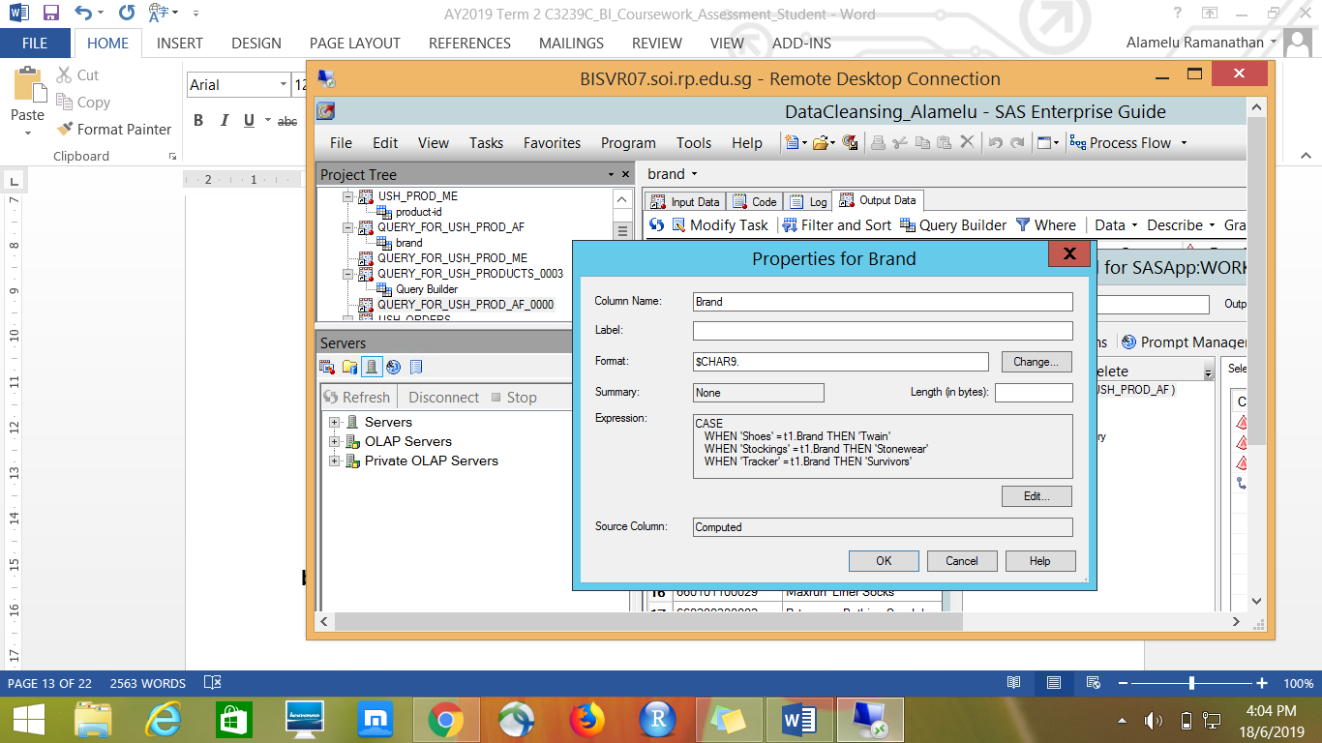

Generated GrossProfit for all the products from Selling Price & Cost Price.

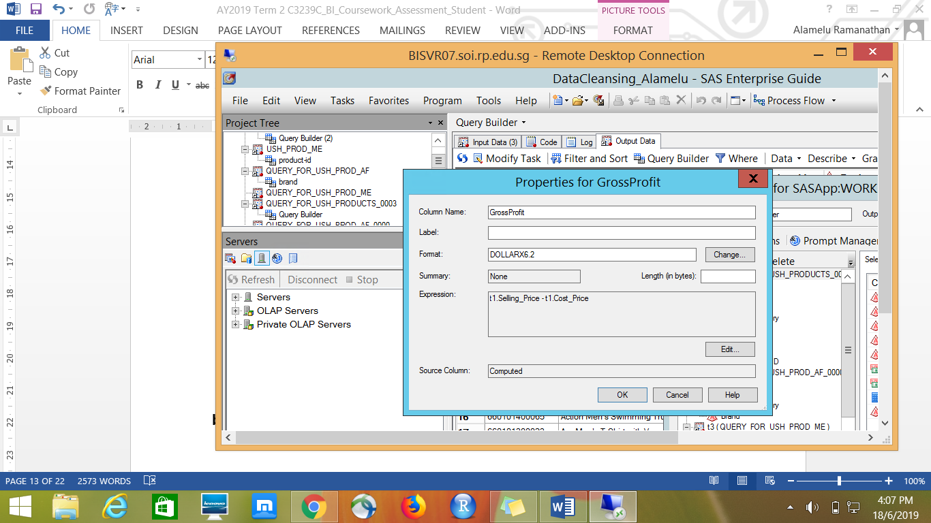

Standardized Product_ID in Orders table

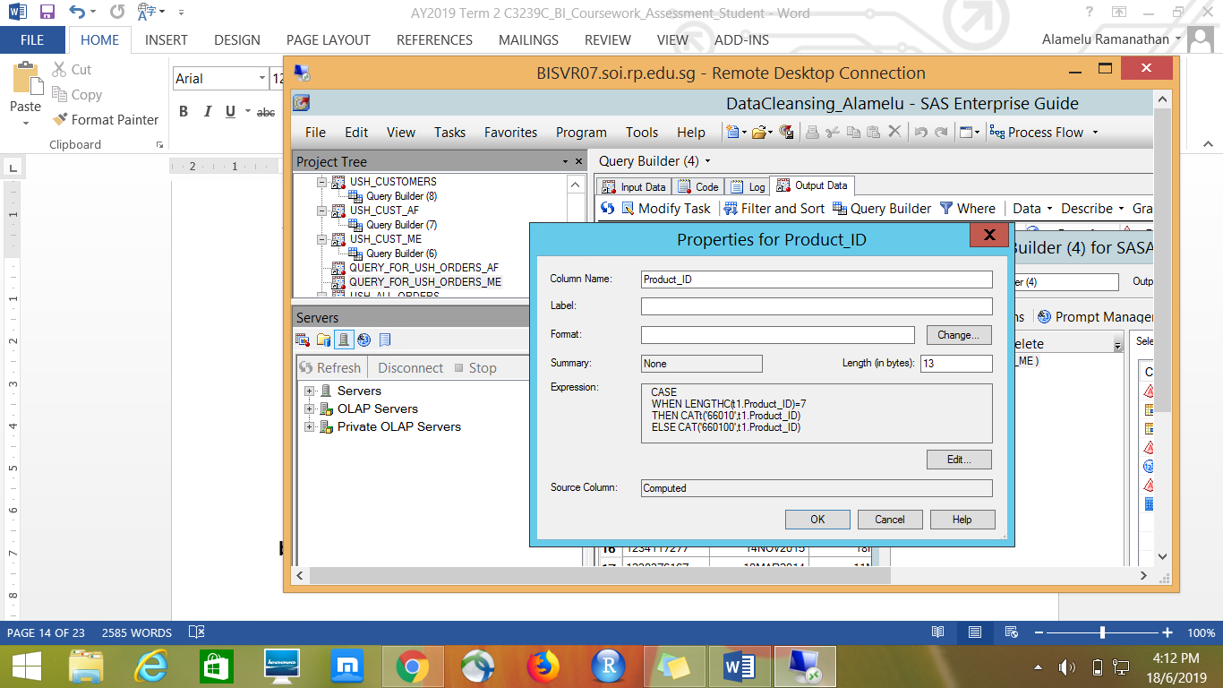

Standardized Customer_ID using SCAN function across all the regions by removing the characters after delimiters like hyphen and underscore.

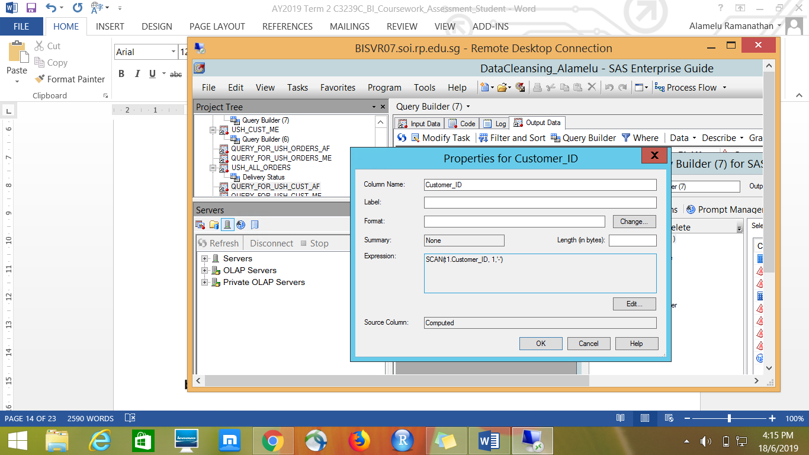

Calculated Age of all customers based on the birth year.

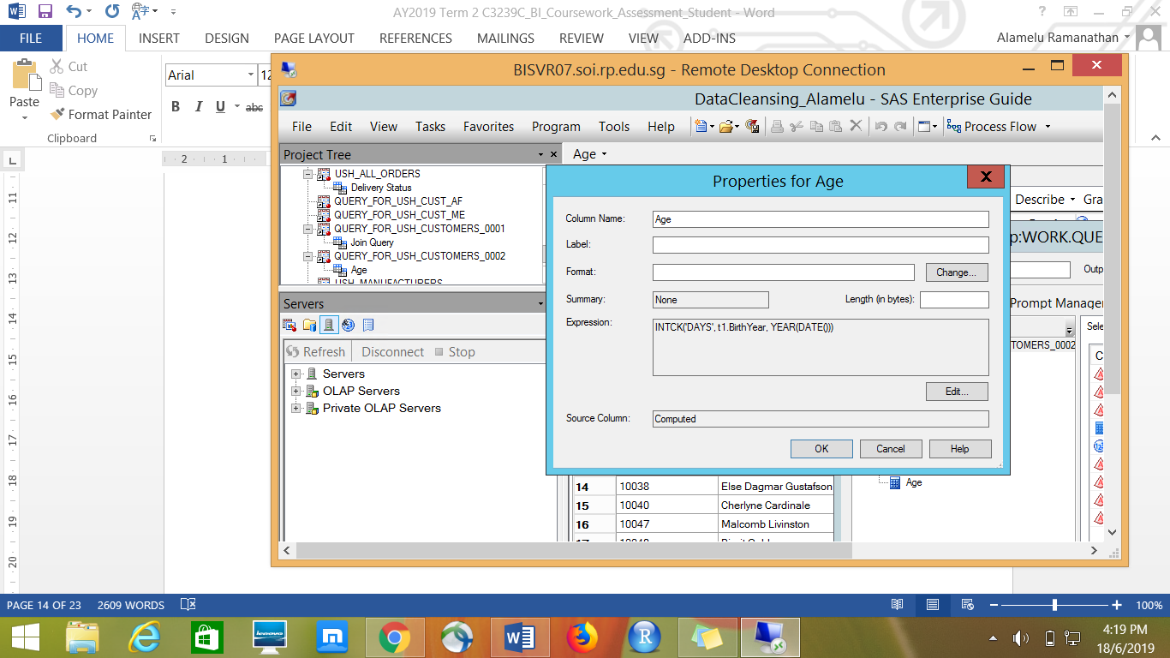

1. **DATA ANALYSIS**

Distribution of Manufacturer Country – Based on the frequency analysis in the oneway frequency its clear that US occupies major portion in distribution.

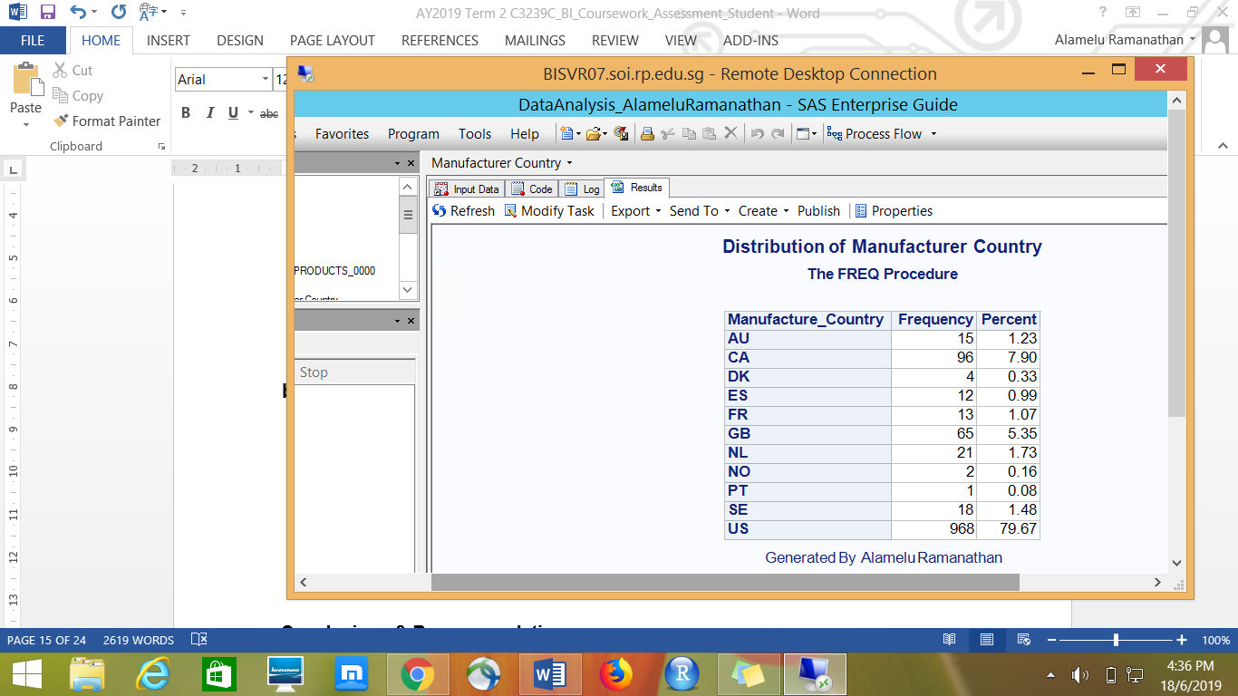

Gross Profit based on Manufacturer Country

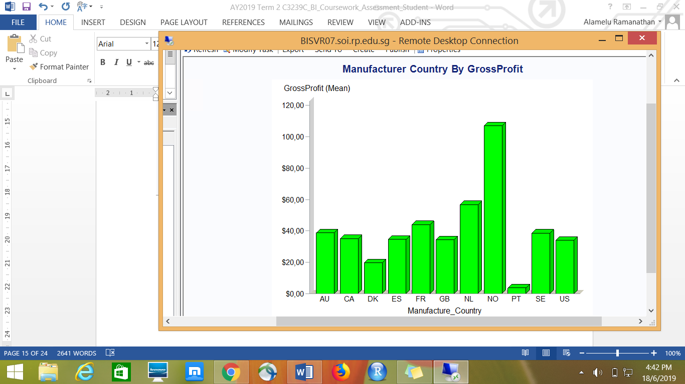

Insight – Manufacturer country NO & NL generates more revenue. USH management can foucs on these manufacturer country to improve their business.

Top 15 best selling products with more Gross Profit-

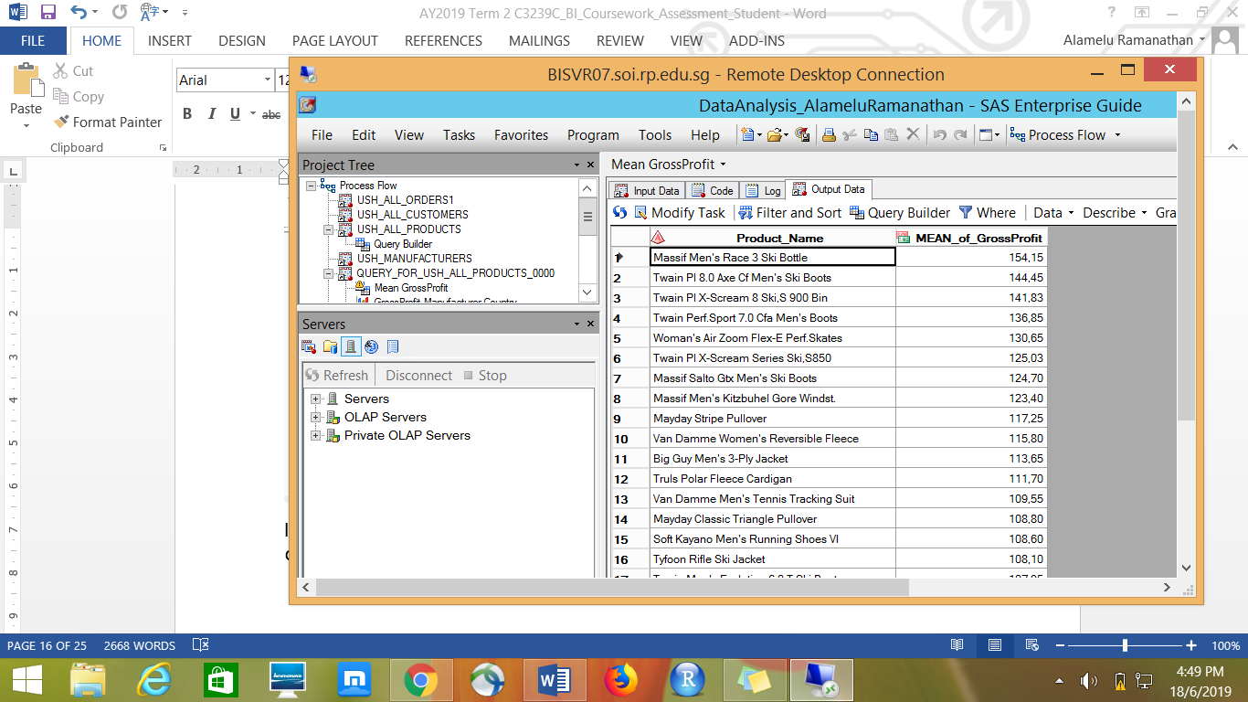

Insight- Massif Men’s Race 3 Ski Bottle is the best selling product with a highest profit of $154.15.

Order Type that generates more revenue-

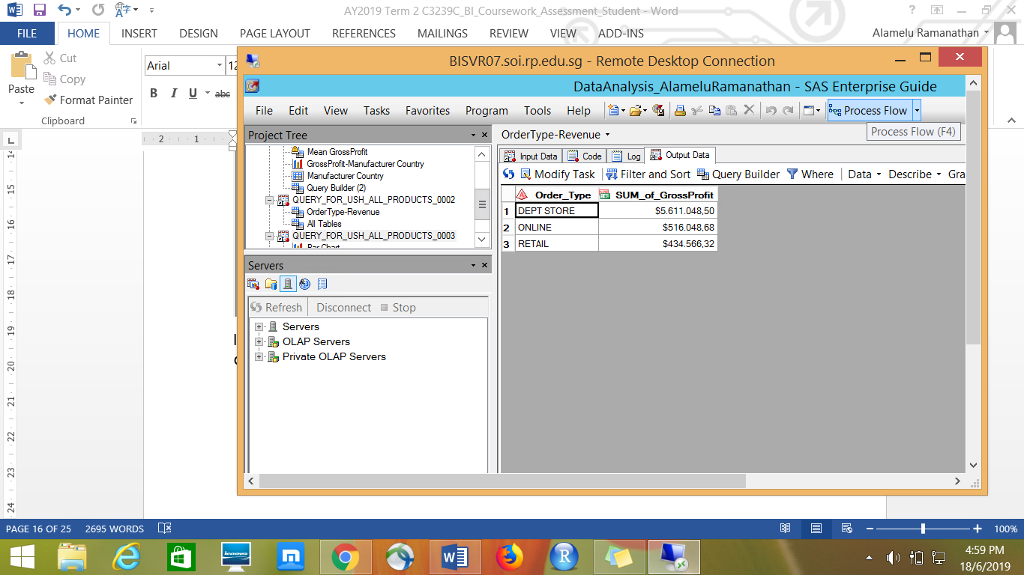

Insight- Dept Store generates highest revenue of $5,611,048.50. Online & Retail revenue is very little.

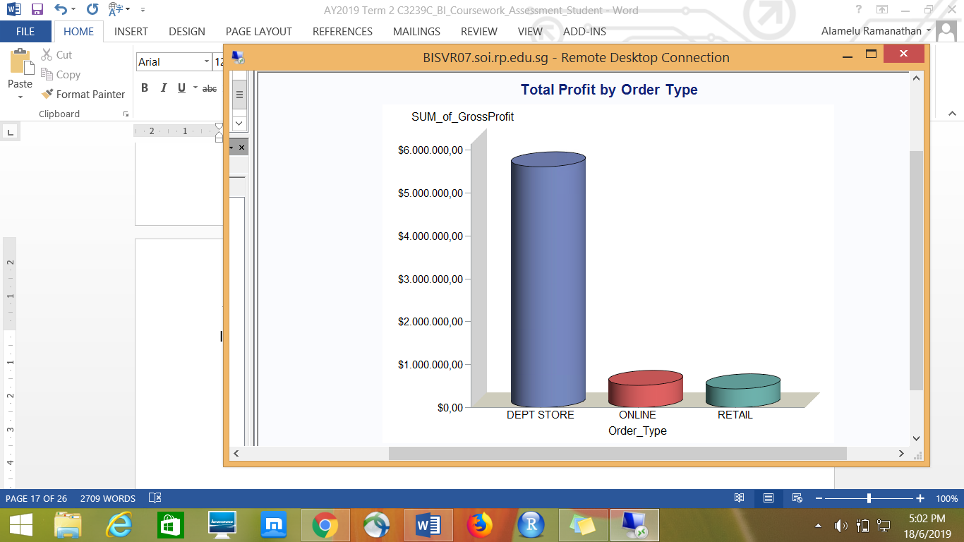

Top 15 customers in terms of total amount spent by each one-

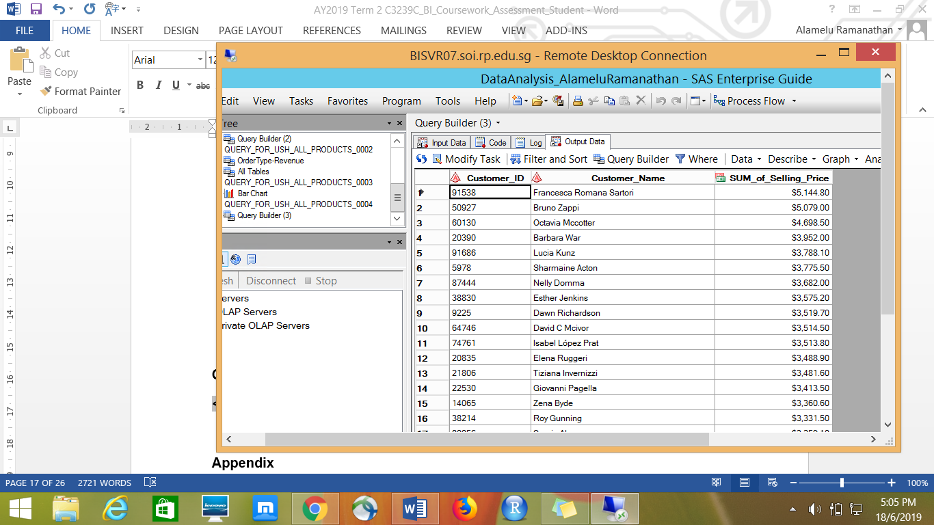

Insights- Barbara War is the top 4 th customer who spent a total amount of $3952.00

**Which Manufacturers products to continue or discontinue?**

Used Query builder to extract the necessary fields like Product_ID, Product_Name,Manufacturer_ID, Manufacturer_Name, COUNT of Quantity, AVERAGE Gross Profit and sort all the records based on Quantity in Descending order.

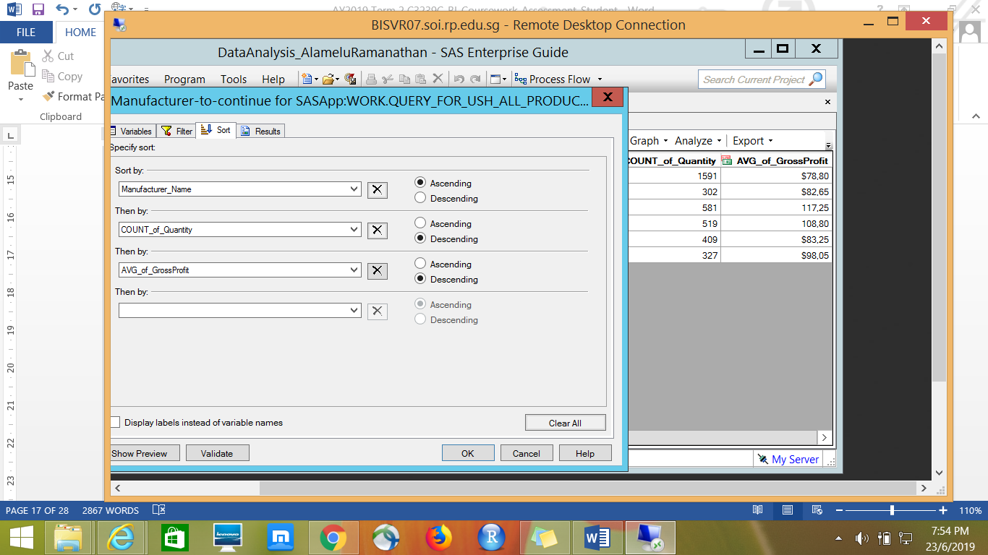

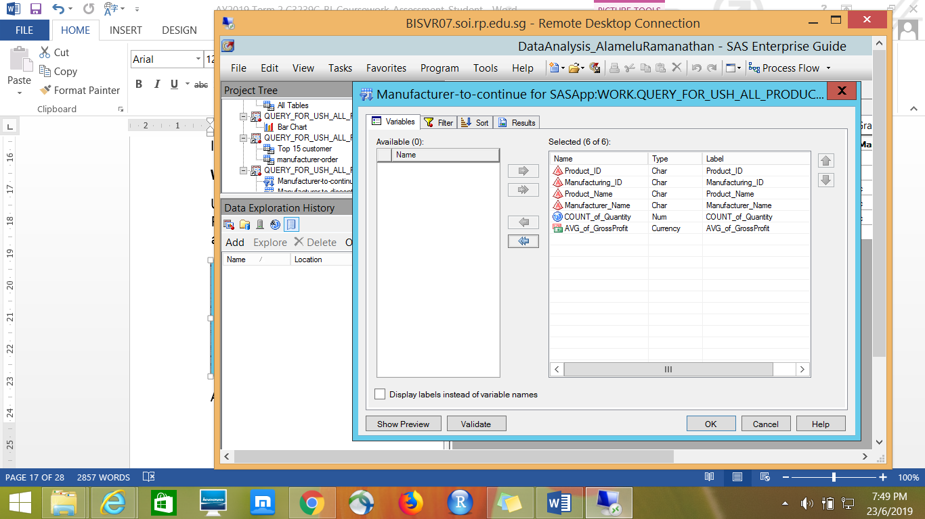

Applied filter to extract the product quantity more that 300 and Average Gross profit greater than $75.

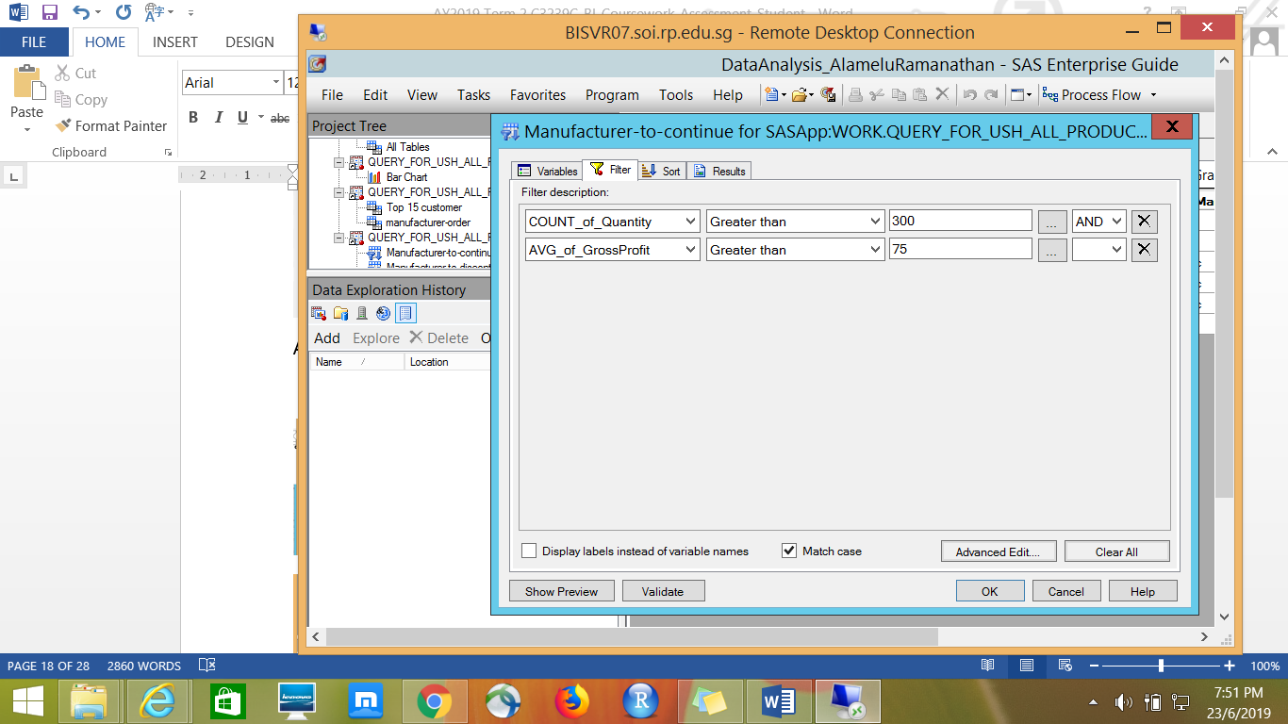

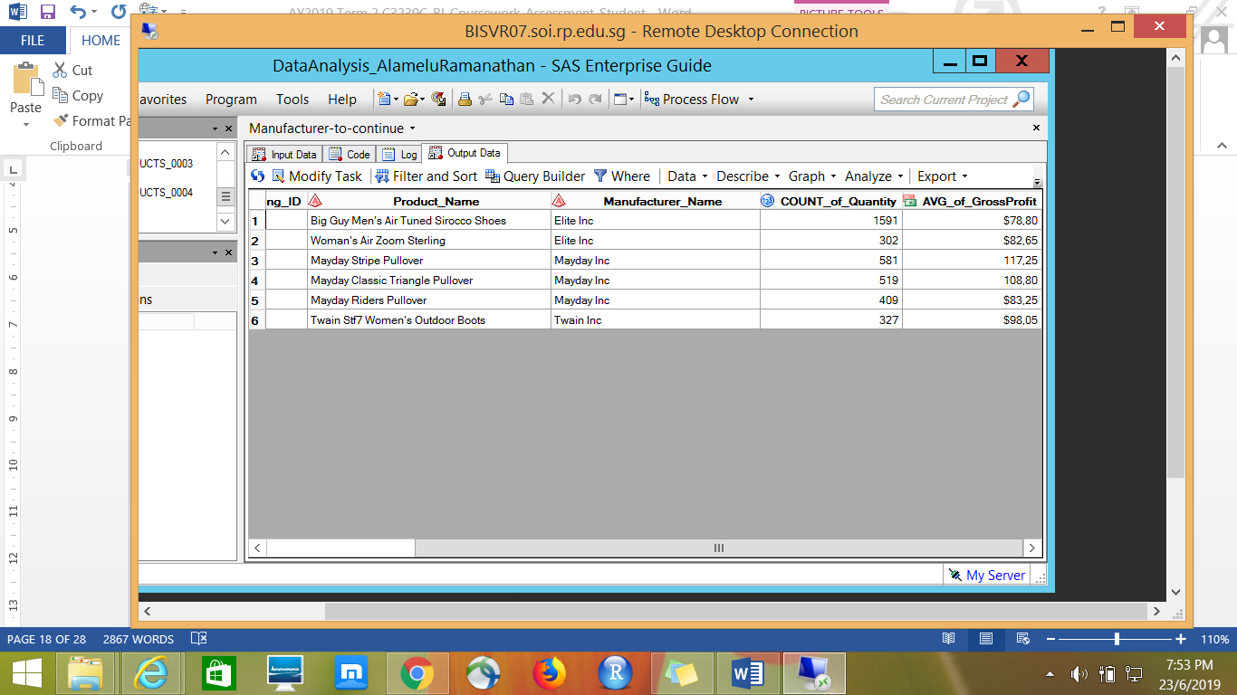

Similarly, applied filters to extract the COUNT of quantity less than 50 and Average Gross Profit less tha $10, to identify the manufacturers to discontinue.

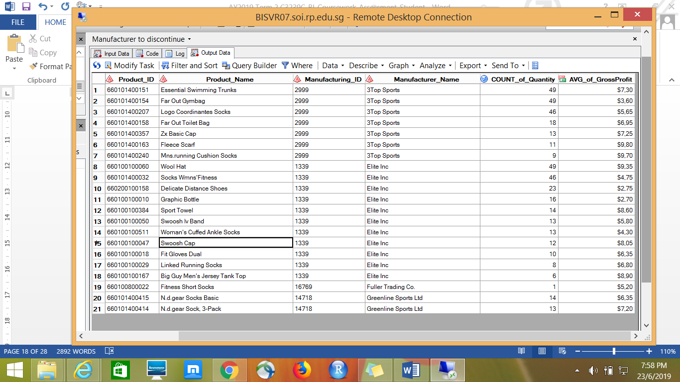

Insights – Based on the COUNT of the qauntity of products and AVERAGE gross profit the manufacturers Elite Inc, Manday Inc & Twain Inc are strongly recommended to be continued by USH management.

USH management should consider to discontinue Zx Herit Pants from Fuller Trading Co, Sunbeach Bermuda Shorts from 3Top Sports and Greenline Sports Ltd as their produts are sold in very less quantity across all the regions.

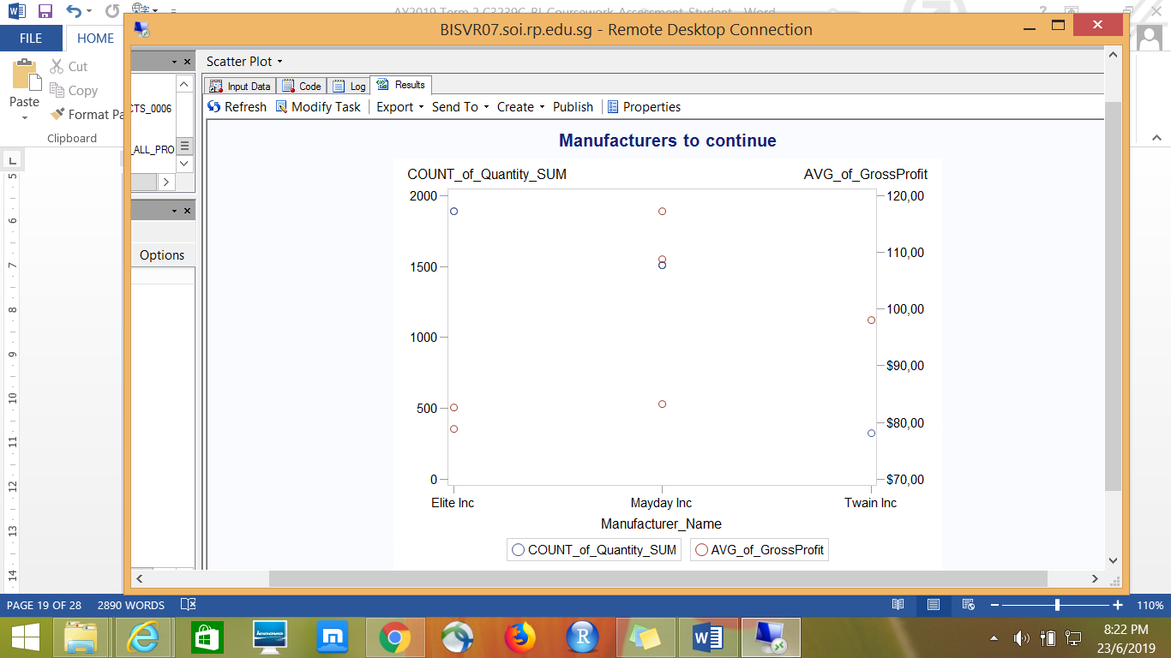

**Which region(s) should USH expand or cut back?**

In sight – Europe takes up the highest portion in terms of total gross profit and quantity sold, then followed by North America and Australia /Pacific. USH should consider to expand their business in Europe and cut down at Australia / Pacific regions.

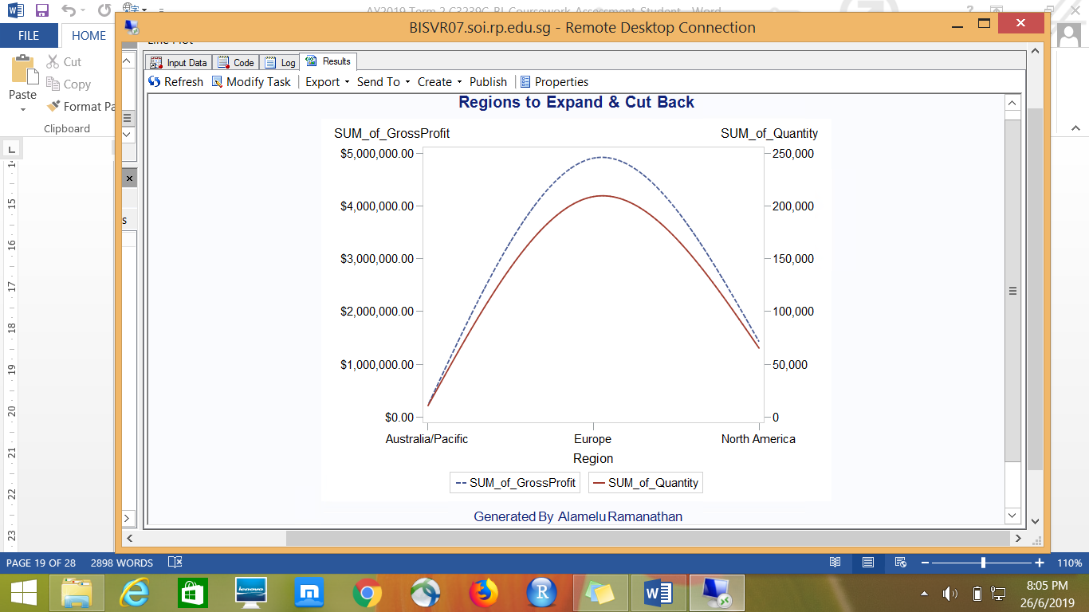

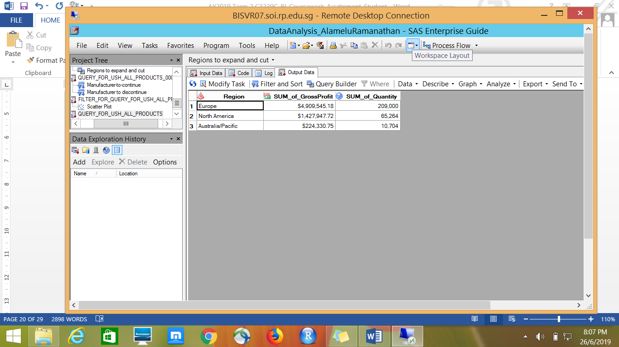

Summary Statistics of Global Membership Schemes-

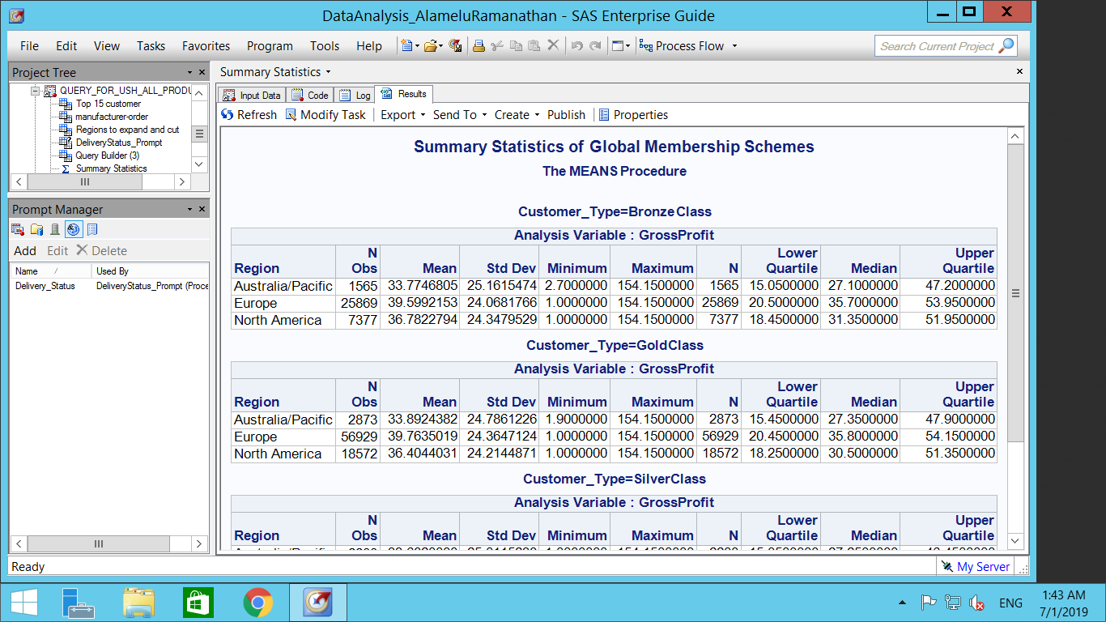

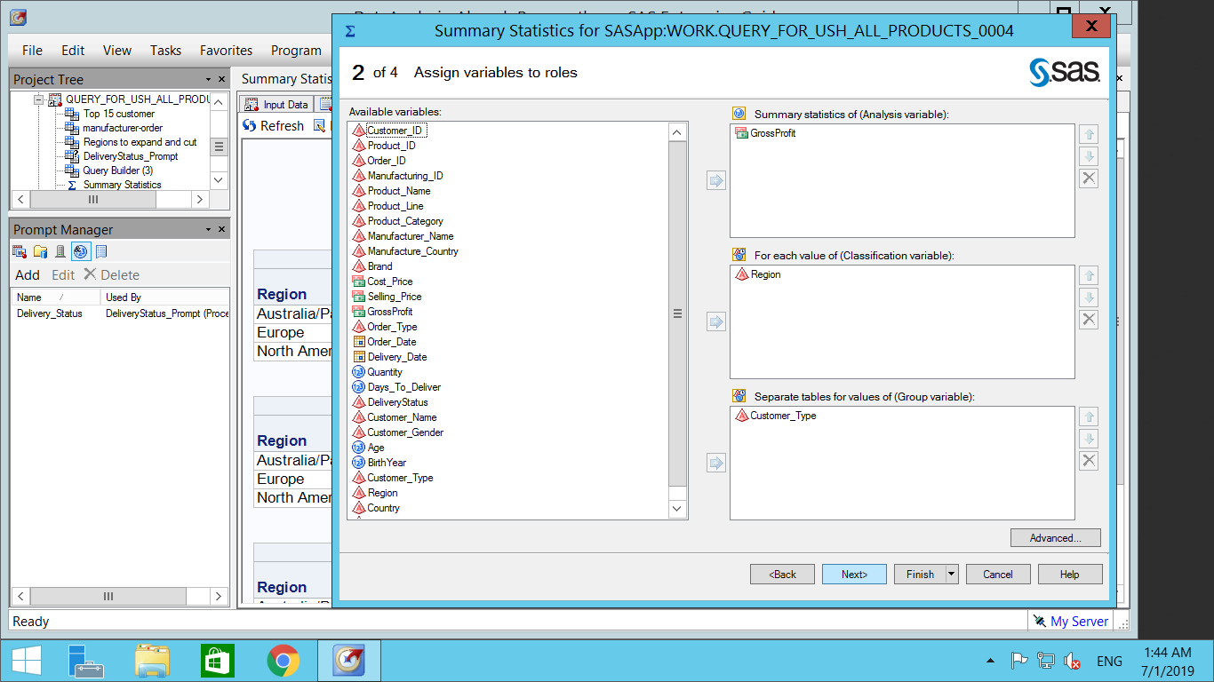

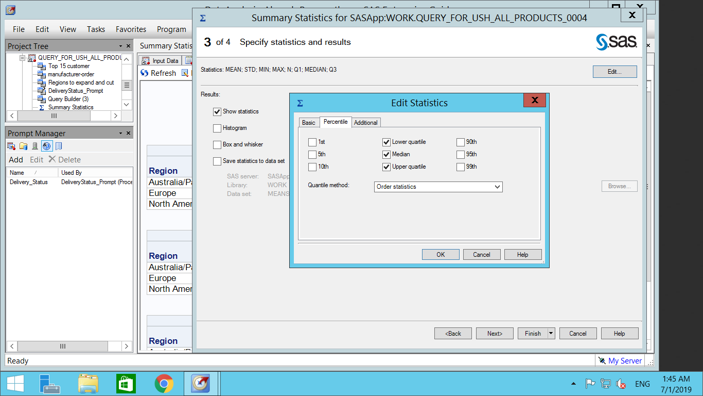

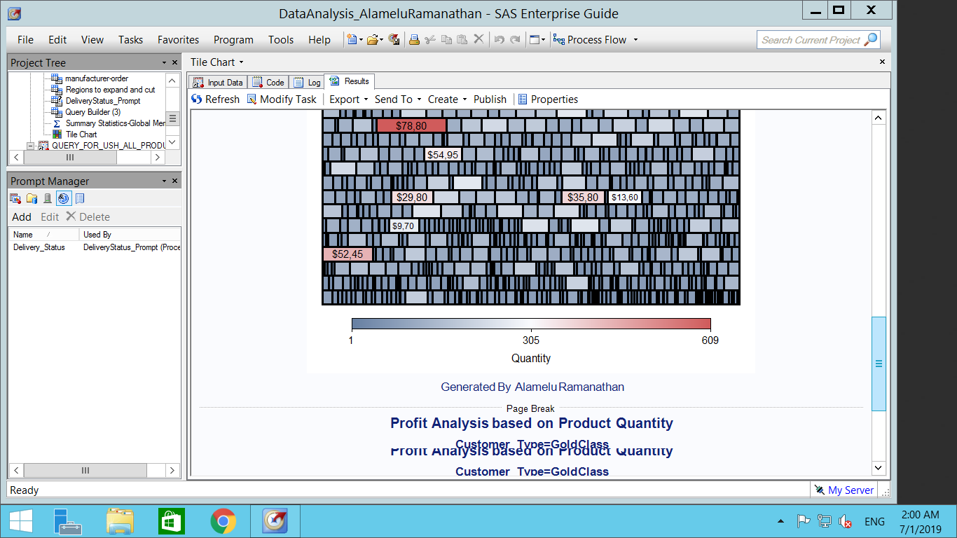

1-Way Frequency Table to identify the number of days to deliver

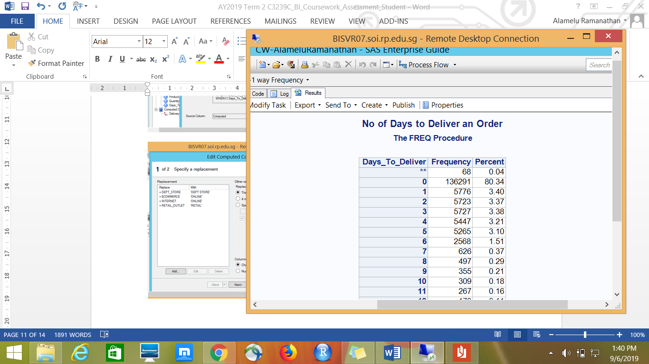

Insight – about 80% of the customers receive their orders immediately and about 10% of the customers received orders in 2 to 5 days.

Count of Customer Type based on Region

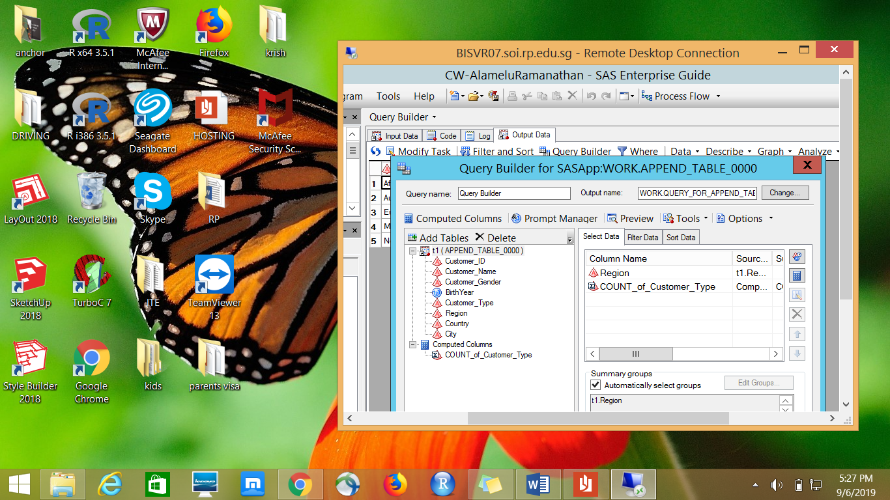 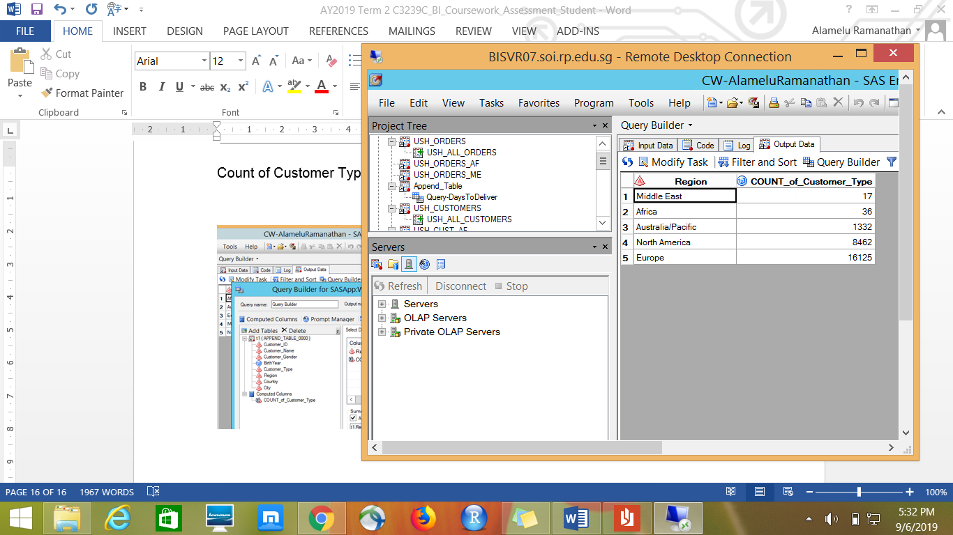

Insights – There are least customers from Middle East & Africa, most cutomers are from Europe & North America.

Number of Customers based on Region in%

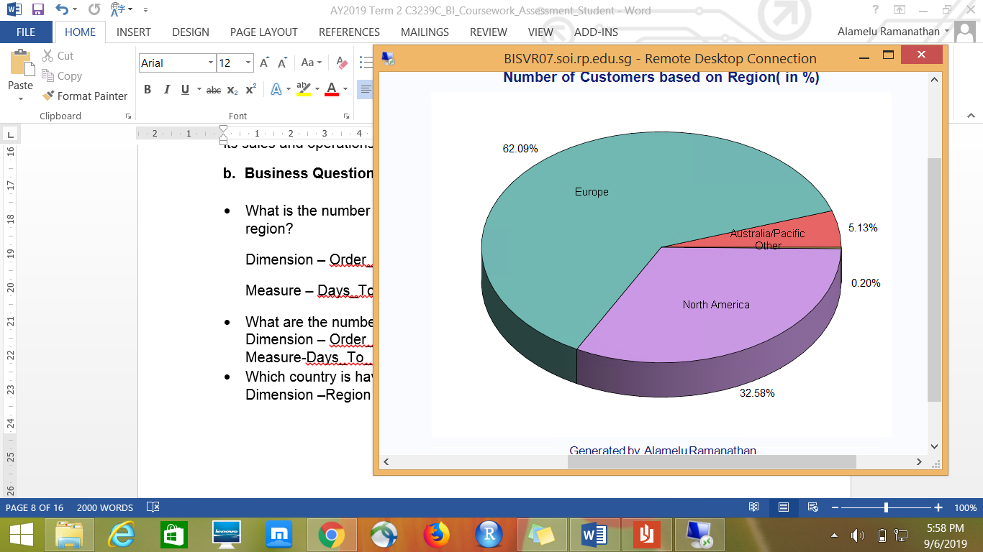

Australia/Pacific has least number of Customers and we highlighted this by separating the “Australia/Pacific” slice in the pie chart from the rest as shown below:

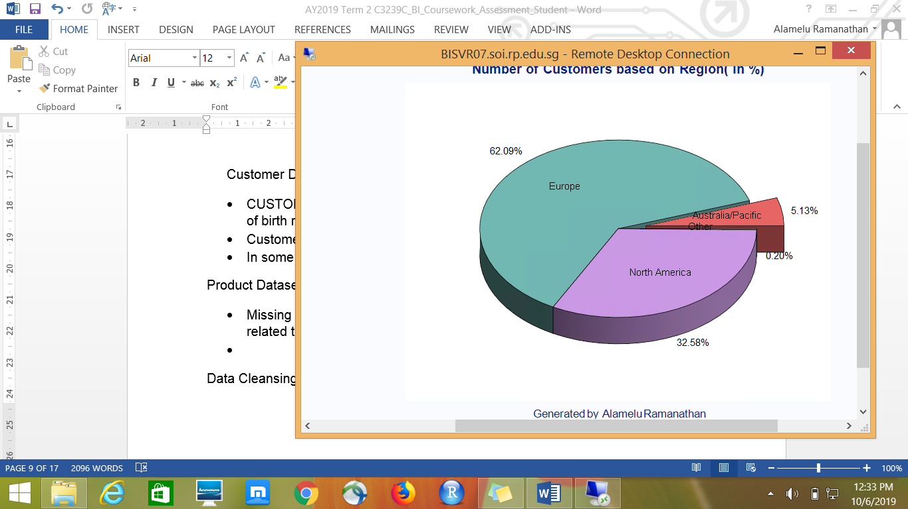

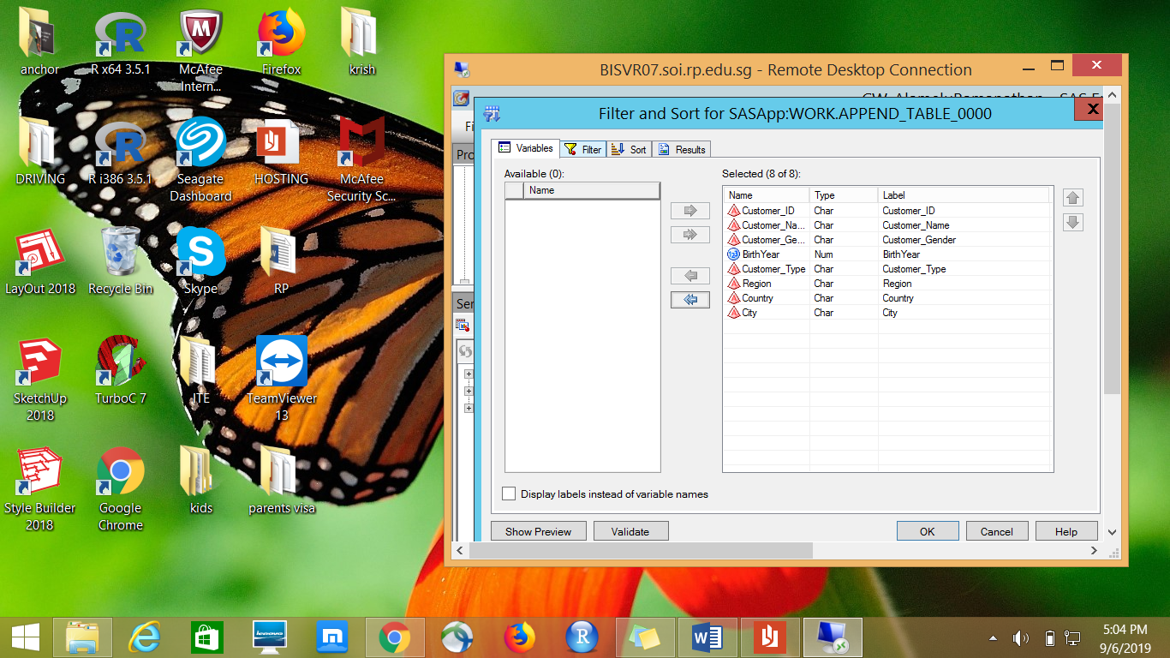Filter & extracted all Male customer data from Middle East. Sort the result based on customers birth year by ascending.

g.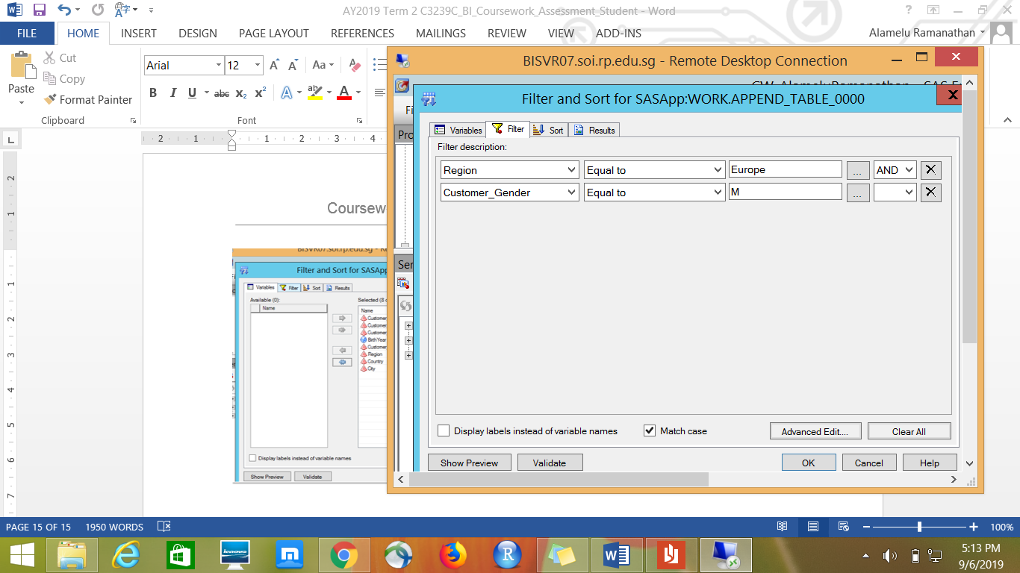

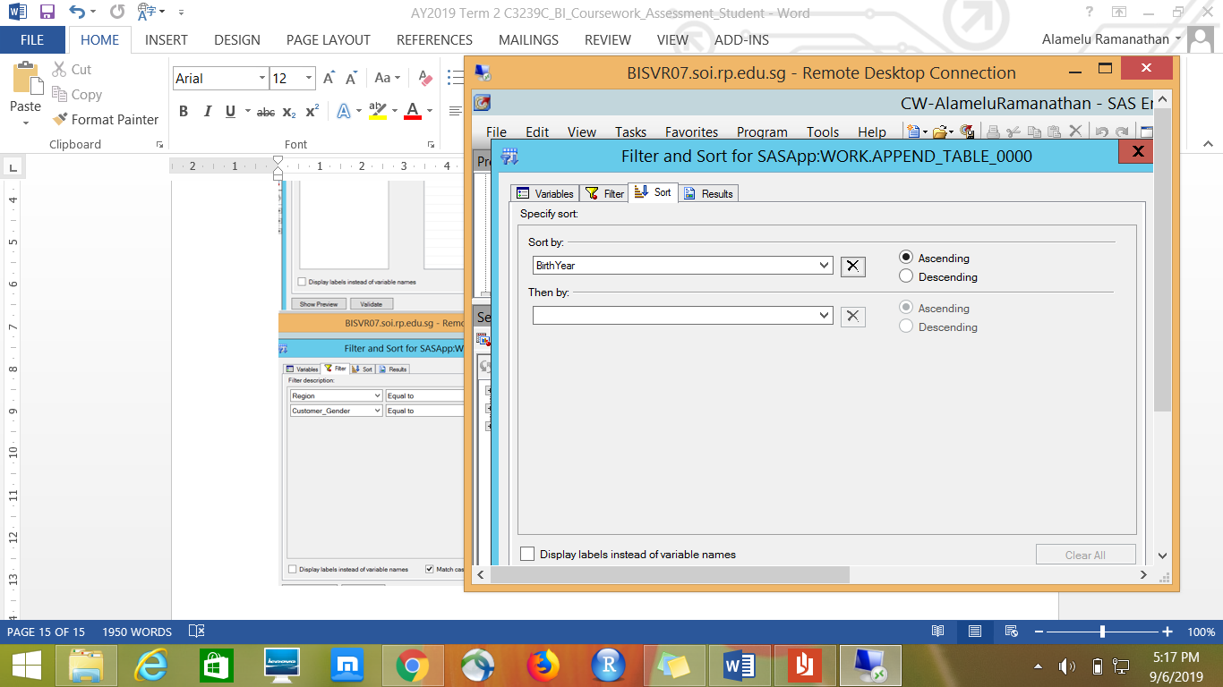

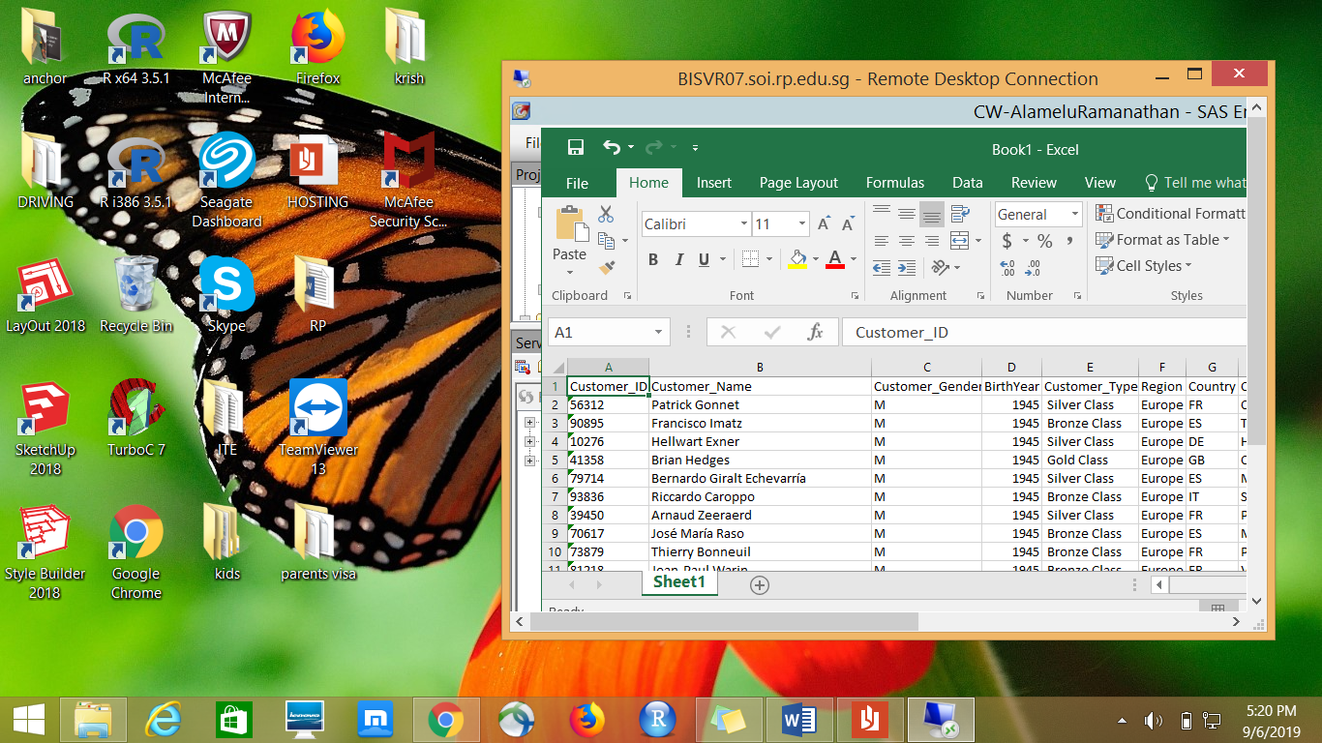

InnerJoin – Order details together with Customer information to get more meaningful.

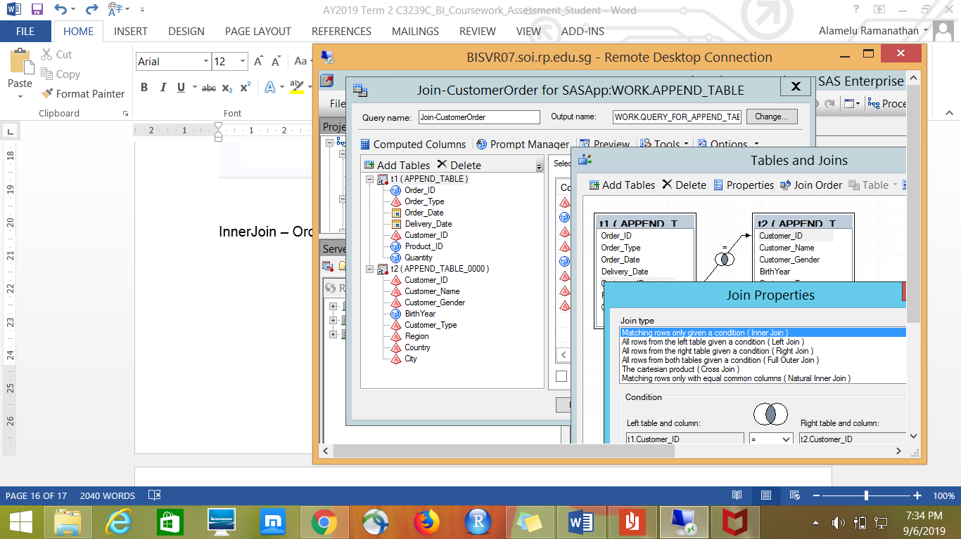

Prompts to display records based on Delivery status.

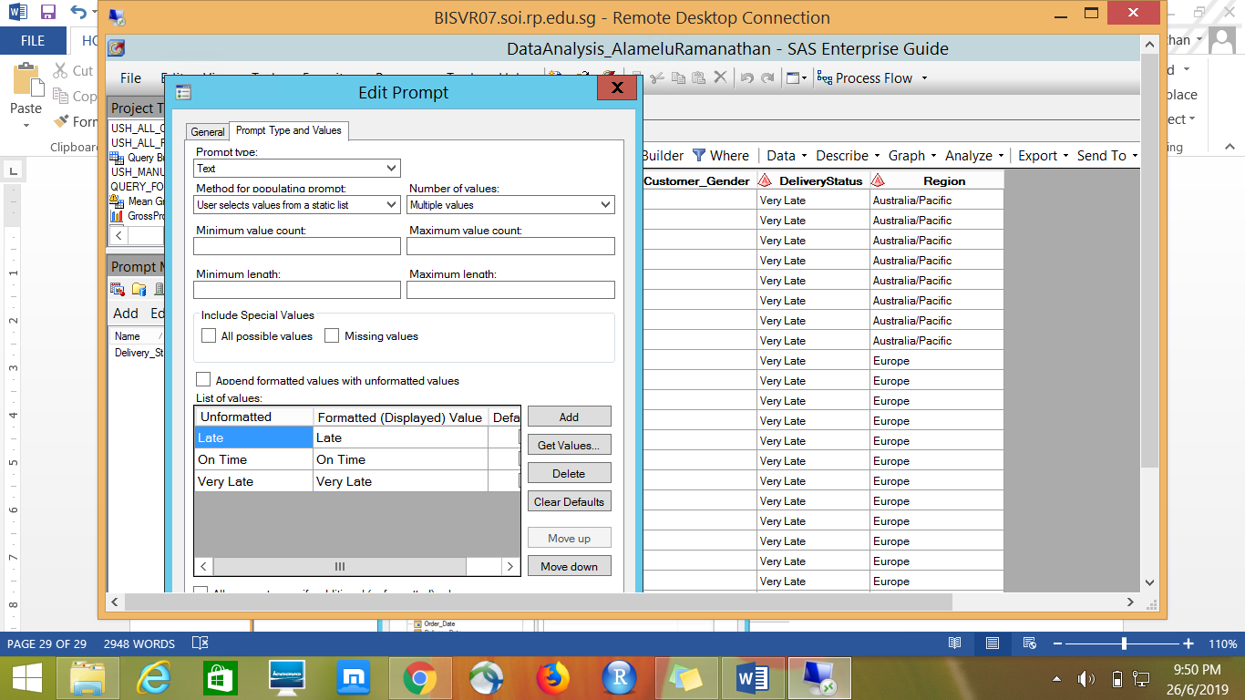

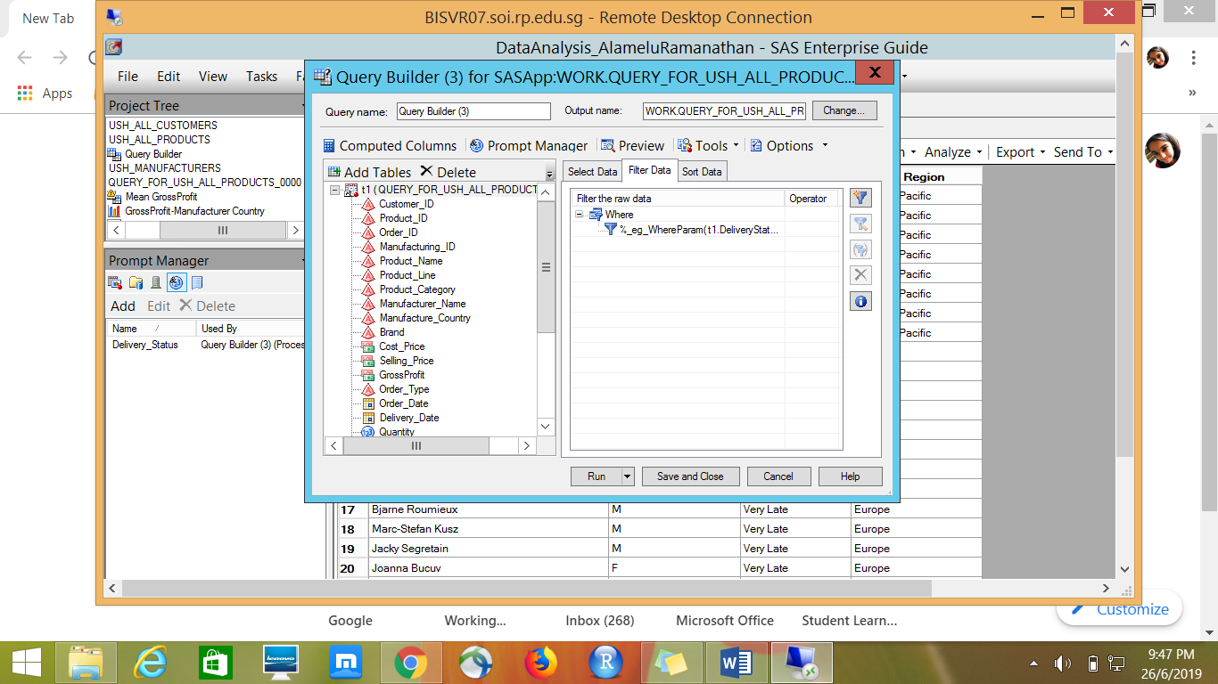

### CONCLUSIONS & RECOMMENDATIONS

USH Sporting House is converted into an Integrated Supply Chain System from disparate systems. This will provide the management more holistic information system about its sales, customers, products and manufacturers across all regions.

Based on the integrated data and reports, USH can expand their business in Europe as there are more demands for their products. Europe takes up the highest portion in terms of total profit. Sales for Middle East and Africa is almost negligible. There are least customers from Middle East & Africa, most cutomers are from Europe & North America.

Almost about 80% of the customers receive their orders immediately and about 10% of the customers received orders in 2 to 5 days. So, USH Sporting House can follow the same methods of delivery to maintain customer satisfaction. Based on the COUNT of the qauntity of products and AVERAGE gross profit the manufacturers Elite Inc, Manday Inc & Twain Inc are strongly recommended to be continued by USH management.

Manufacturer country NO & NL generates more revenue. USH management can foucs on these manufacturer country to improve their business. Based on the frequency analysis in the oneway frequency its clear that US occupies major portion in distribution.